// C program to demonstrate delete operation in binary search tree
#include<stdio.h>
#include<stdlib.h>

struct node
{
int key;
struct node *left, *right;
};

// A utility function to create a new BST node
struct node *newNode(int item)
{
struct node *temp = (struct node *)malloc(sizeof(struct node));
temp->key = item;
temp->left = temp->right = NULL;
return temp;
}

// A utility function to do inorder traversal of BST
void inorder(struct node *root)
{
if (root != NULL)
{
inorder(root->left);
printf("%d ", root->key);
inorder(root->right);
}
}

/* A utility function to insert a new node with given key in BST */
struct node* insert(struct node* node, int key)
{
/* If the tree is empty, return a new node */
if (node == NULL) return newNode(key);

/* Otherwise, recur down the tree */
if (key < node->key)
node->left = insert(node->left, key);
else
node->right = insert(node->right, key);

/* return the (unchanged) node pointer */
return node;
}

/* Given a non-empty binary search tree, return the node with minimum
key value found in that tree. Note that the entire tree does not
need to be searched. */
struct node * minValueNode(struct node* node)
{
struct node* current = node;

/* loop down to find the leftmost leaf */
while (current && current->left != NULL)
current = current->left;

return current;
}

/* Given a binary search tree and a key, this function deletes the key
and returns the new root */
struct node* deleteNode(struct node* root, int key)
{
// base case
if (root == NULL) return root;

// If the key to be deleted is smaller than the root's key,
// then it lies in left subtree
if (key < root->key)
root->left = deleteNode(root->left, key);

// If the key to be deleted is greater than the root's key,
// then it lies in right subtree
else if (key > root->key)
root->right = deleteNode(root->right, key);

// if key is same as root's key, then This is the node
// to be deleted
else
{

// node with only one child or no child
if (root->left == NULL)
{
struct node *temp = root->right;
free(root);
return temp;
}
else if (root->right == NULL)
{
struct node *temp = root->left;
free(root);
return temp;
}

// node with two children: Get the inorder successor (smallest
// in the right subtree)
struct node* temp = minValueNode(root->right);

// Copy the inorder successor's content to this node
root->key = temp->key;

// Delete the inorder successor
root->right = deleteNode(root->right, temp->key);
}
return root;
}

// Driver Program to test above functions
int main()
{
/* Let us create following BST
50
/ \
30 70
/ \ / \
20 40 60 80 */
struct node *root = NULL;
root = insert(root, 50);
root = insert(root, 30);
root = insert(root, 20);
root = insert(root, 40);
root = insert(root, 70);
root = insert(root, 60);
root = insert(root, 80);

printf("Inorder traversal of the given tree \n");
inorder(root);

printf("\nDelete 20\n");
root = deleteNode(root, 20);
printf("Inorder traversal of the modified tree \n");
inorder(root);

printf("\nDelete 30\n");
root = deleteNode(root, 30);
printf("Inorder traversal of the modified tree \n");
inorder(root);

printf("\nDelete 50\n");
root = deleteNode(root, 50);
printf("Inorder traversal of the modified tree \n");
inorder(root);

return 0;
}

Output:
Inorder traversal of the given tree
20 30 40 50 60 70 80
Delete 20
Inorder traversal of the modified tree
30 40 50 60 70 80
Delete 30
Inorder traversal of the modified tree
40 50 60 70 80
Delete 50
Inorder traversal of the modified tree
40 60 70 80

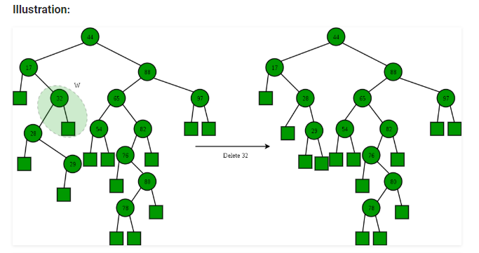

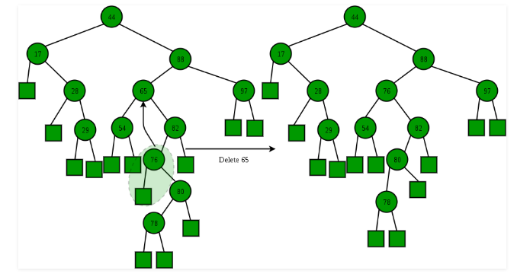
Time Complexity: The worst case time complexity of delete operation is O(h) where h is height of Binary Search Tree. In worst case, we may have to travel from root to the deepest leaf node. The height of a skewed tree may become n and the time complexity of delete operation may become O(n)

